**Individual Tableau Assignment: Using Custom Images and Dashboard Actions**

The goals of this exercise are to help you practice:

* Using outside resources to learn how to do something new in Tableau
* Creating graphs at key locations in custom background images
* Filtering your data with custom images
* Implementing dashboard actions
* Making images appear dynamically in your dashboards
* Allowing users to email you
* Providing instructions for your visualizations
* Editing your tooltips

Please submit a document with your answers to the assignment questions AND a packaged workbook extract of your completed Tableau workbook through Sakai. Make sure your name is included in the title of your submissions and that your packaged workbook is fully functional for somebody who will be opening the workbook on another computer.

Here is a reminder about how to create a packaged workbook:

<http://onlinehelp.tableau.com/current/pro/desktop/en-us/save_savework_packagedworkbooks.html>

If you encounter problems while working through these exercises that you cannot solve on your own, you can:

* Use resources that you find online about how to make specific types of graphs in Tableau
* Ask questions in the Tableau Questions Discussion board in Piazza
* Ask the TAs for help

In the text below, all variable names will be depicted in *italics* and all properties on the Marks Card will be depicted in **bold**.

You will need the following data sets and files to finish this assignment (all are provided in the course website):

* nss15.csv
* Body_Part_Image_and_Codes.xlsx
* Data Dictionary & Code Guide for Injury Data Set.pdf
* body_template.png
* First_aid_icon.png
* information_icon.png
* Home, farm, street, public property, mobile home, industrial, school, and recreation icons

The data represents CPSC’s National Electronic Injury Surveillance System (NEISS)’s data from 2015 describing emergency room visits that were due to injuries caused by consumer products. ***You do not need to do any data cleaning other than the few steps stated explicitly in the instructions.***

**Exercise 1: Plot the number of injuries to specific body parts on an image**

To prepare for this exercise, watch this video:

<https://www.tableau.com/learn/tutorials/on-demand/background-images?product=&version=10.3&topic=mapping>

You may also want to read this post:

<http://www.evolytics.com/blog/how-to-map-anything-in-tableau/>

The instructions I will give you about how to implement this type of visualization are slightly different than what is shown in the video (without an extra excel spreadsheet step), but you are welcome to implement the visualization either way.

Your goal for this exercise is to recreate this visualization, where the size of the closed circles represents the number of injuries that were reported for that region of the body in the nss15 data set.

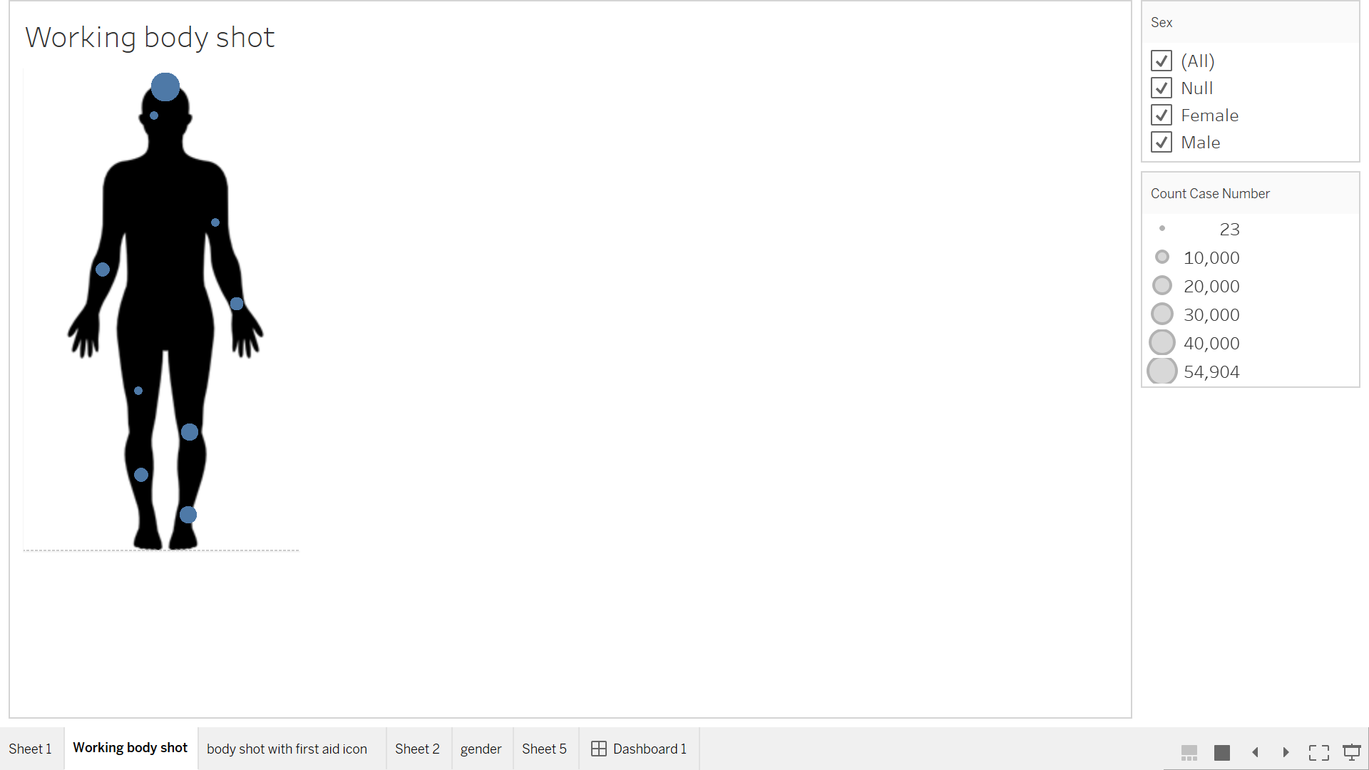

The body parts you will examine for this exercises are:

Wrist, Lower arm, Upper arm, Eyeball, Head, Upper leg, Knee, Lower leg, and Ankle

***Ignore/filter out any other body parts in the data set for the rest of this assignment.***

To begin, examine both the nss15 file and the Body_Part_Image file. The Body_Part_Image file, in addition to having an X and Y field, has the body part label for each of the body part entries in the nss15 file, so you will need to join the files in Tableau.

Next, determine how wide and tall the body_template image that I supplied for you is in pixels, (<https://knowledgebase.constantcontact.com/articles/KnowledgeBase/5616-determine-an-image-s-file-size-and-dimensions>) and write down the values.

Open up Tableau, connect to both data sets (make sure you choose to connect to the appropriate type of data), and join them appropriately. Then go to your workspace.

Go to Map > Add Background Image, and navigate to the body image on your computer in the “File or URL” field. (The steps that follow are slightly different than what is shown in the video.) Assign the *X* variable to the “X Field” and the *Y* variable to the “Y field”. You will need to make the *X* field/axis extend to the width (in pixels) of your image and the *Y* field/axis extend to the height (in pixels) of your image. Enter the appropriate width in the Left/Right boxes and the appropriate height in the Bottom/Top boxes. In the Options tab, click the “Lock Aspect Ratio” and “Always Show Entire Image” options. Then press OK. Back in your workspace, put *X* and *Y* on the appropriate places in your workspace. You should now see the image.

Open the Body_Part_Image file. Following the instructions shown in the video, get the X and Y coordinates of each of the body parts, and enter them by hand into the X and Y fields in the excel file as you go. Make sure you put Wrist, Upper arm, Knee, and Ankle on the right side of the body, and Lower arm, Eyeball, Upper leg, and Lower leg on the left side of the body. Put Head centered on the top of the head (see image above). Once you have all of your coordinates, save the Body_Part_Image file, and refresh the data source. Back in your workspace, you should see some kind of mark in every location you annotated. Format the marks so that they are closed circles.

Your next goal is to make the size of each mark on the body represent the number of injury cases present in the data set for that body part. Try to do this using the Marks card. Depending on how your data is blended/joined, you will likely find that each mark is the same size. If so, when you hover over a mark, it will show you an X value, a Y value, and a case number count of 1. This is because Tableau is aggregating at the level of X/Y pairs instead of case numbers. An easy way to handle this is to write an LOD calculation to sum the number of cases at the level you want. For illustration purposes, write an LOD calculation using the FIXED function that counts the number of cases for each body part. When you put that calculation on the marks card in the appropriate place, you should be able to see different-sized marks that represent the number of cases associated with each body part. In another worksheet, make a table that counts the number of cases associated with each body part and make sure the numbers match those illustrated by the marks on top of the body image. Once you have verified that the calculations are correct, format the marks so that they have no borders or halos. Label your worksheet “Injuries by Body Part (circles)”.

1. **Paste the LOD calculation that you used in your submission.**

**Ans: ﻿{ FIXED [Body Part] : COUNT([Case Number]) }**

1. **Include the worksheet in your submitted workbook.**

**Included in submission workbook.**

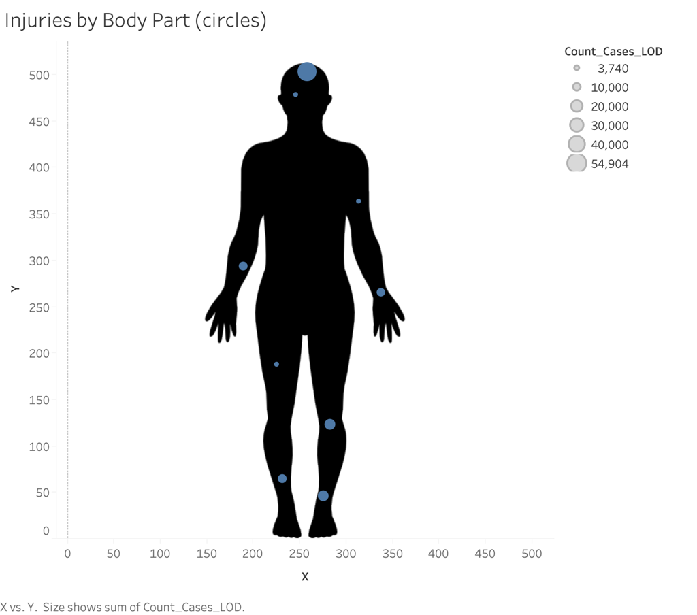

**Exercise 2: Segment the plot from Exercise 1 by gender, and filter by location**

Duplicate your worksheet. Call the new worksheet “Injuries by Body Part, Sex, Location”. Your first goal is to make two different plots right next to each other, one for men and one for women. Doing this is as simple as adding the *Sex* variable to your columns or rows shelf. However, if you hover over the values of the marks, you will see that they are the same for both images. That’s because the FIXED LOD function tells Tableau to calculate the aggregate function in the second half of the equation at the level of the dimension(s) that you entered immediately after “FIXED”, *no matter what else is in your workspace*. To make the LOD calculation take what’s in the workspace into account, you must use either use the INCLUDE or the EXCLUDE function. INCLUDE will compute the values of the aggregate function to the left of specified dimension *in addition* to the other dimensions in the workspace, while EXCLUDE will remove the specified dimension from the computation of the aggregate function to the left of specified dimension, *regardless of what is in the workspace*. INCLUDE expressions are therefore useful when you want to calculate something using a field that is not in your view, and EXCLUDE expressions are useful when you want to ignore a field in the view. Adapt your calculation to use whichever one you think is most appropriate for giving you the correct answers, and check the result using the same strategy as before (by making a table in a separate worksheet and comparing the results to the ones you get in your visualization).

1. **Paste the revised LOD calculation that you implemented in your submission.**

**Ans: ﻿{ INCLUDE [Sex] : COUNT([Case Number]) }**

Next, filter your visualization by location so that you can see where the injuries are occurring. Begin by changing the aliases of the numerical entries in the location field to word strings that represent the location category each number corresponds to (see the Data Dictionary & Code Guide supplied on the course website). Then, create a drop-down quick filter for location that allows you to toggle between the results for different locations, but remove all “Not recorded” values from the filter so that they are not an option in the drop down menu. If you aren’t sure how to do this, see:

<https://community.tableau.com/thread/114469>

Start toggling between the different locations, and make sure to hover over some of the marks as you do so. Depending on how your defaults are set, you might notice that the sizes of the marks seem to stay the same as you click through the different locations, even though the values that they represent when you hover over the mark are vastly different. If so, that’s because the size scales are automatically resizing based on the data in the workspace, which is good in some situations, but in this case is misleading. Set the range of the size encoding so that the scale stays the same no matter what location you are looking at, and choose a minimum and maximum size that you think meets the goals of your visualization best. For instructions about how to implement this mechanically, see:

<http://onlinehelp.tableau.com/current/pro/desktop/en-us/viewparts_marks_markproperties_size.html>

1. **Explain why you chose the minimum and maximum size values that you did.**

Ans: Minimum Size: 3 and Maximum Size: 26,578

These values are chosen based on minimum and maximum counts of cases across all locations.

Finally, remove the *X* and *Y* headers, the title, and the lines between the images. In addition, hide the field label for the columns. You might find this post helpful:

<https://community.tableau.com/thread/201203>

1. **Export the visualization and include it here, with captions. Include the worksheet in your submitted workbook**.

**Included in submission workbook.**

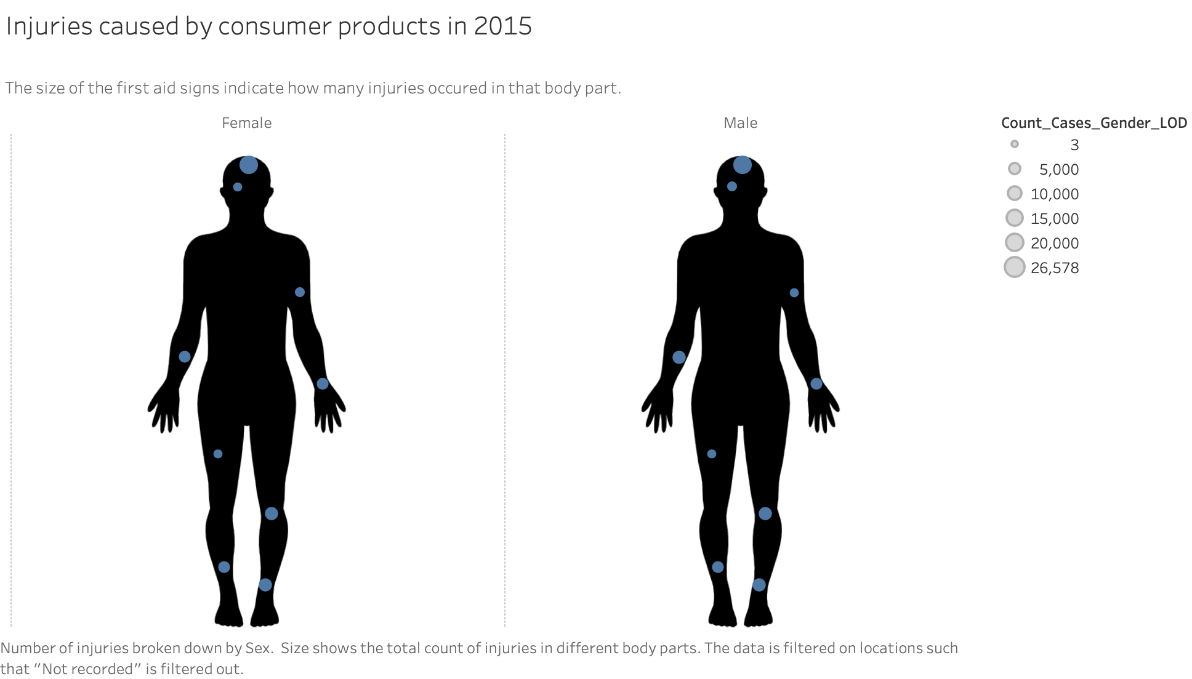

**Exercise 3: Replace the size-encoded marks from Exercise 2 with custom images**

Duplicate your worksheet for Q5, and call the new worksheet “Icon Version of Segmented Injuries”. Your goal is to replace the closed circle marks with the “First_aid_icon” provided in the course materials, and to make the size of the first aid icon represent the appropriate number of cases, just like the circle marks did. To prepare for this, examine these instructions:

<http://onlinehelp.tableau.com/current/pro/desktop/en-us/viewparts_marks_markproperties_shape.html>

Now, follow the instructions to replace the circles with the first aid icon. Once you are sure the icons are being resized appropriately, zoom and navigate within your image to get a view you will be happy with in a dashboard. Go to Map > Map Options, and un-click “Allow Pan and Zoom” to lock the view into place.

1. **Export the visualization and include it here, with captions. Include the worksheet in your submitted workbook.**

**Included in submission workbook.**

**Exercise 4: Prepare to use custom images to filter the graph from Exercise 3 by location, allow users to email you, and provide users with more information**

In Exercise 5, you are going to create a dashboard that allows the user to:

* Click on custom icons to filter the data by location
* Email you
* Get more information about the data set

To prepare for this, you need to make three separate worksheets for the location icons, the email button, and the information button, respectively.

Begin by representing the location categories with icons instead of text. Create a worksheet called “Location Buttons”, and replace the location categories with the icons, as you did before. You are going to do something similar to what is described in the “How to Use Shapes as Buttons” section in the post below, but you are going to organize your shapes in a vertical line instead of a horizontal one:

<https://www.concentra.co.uk/blog/3-great-ways-use-custom-shapes-tableau>

Make sure you assign the icons to location in this way:

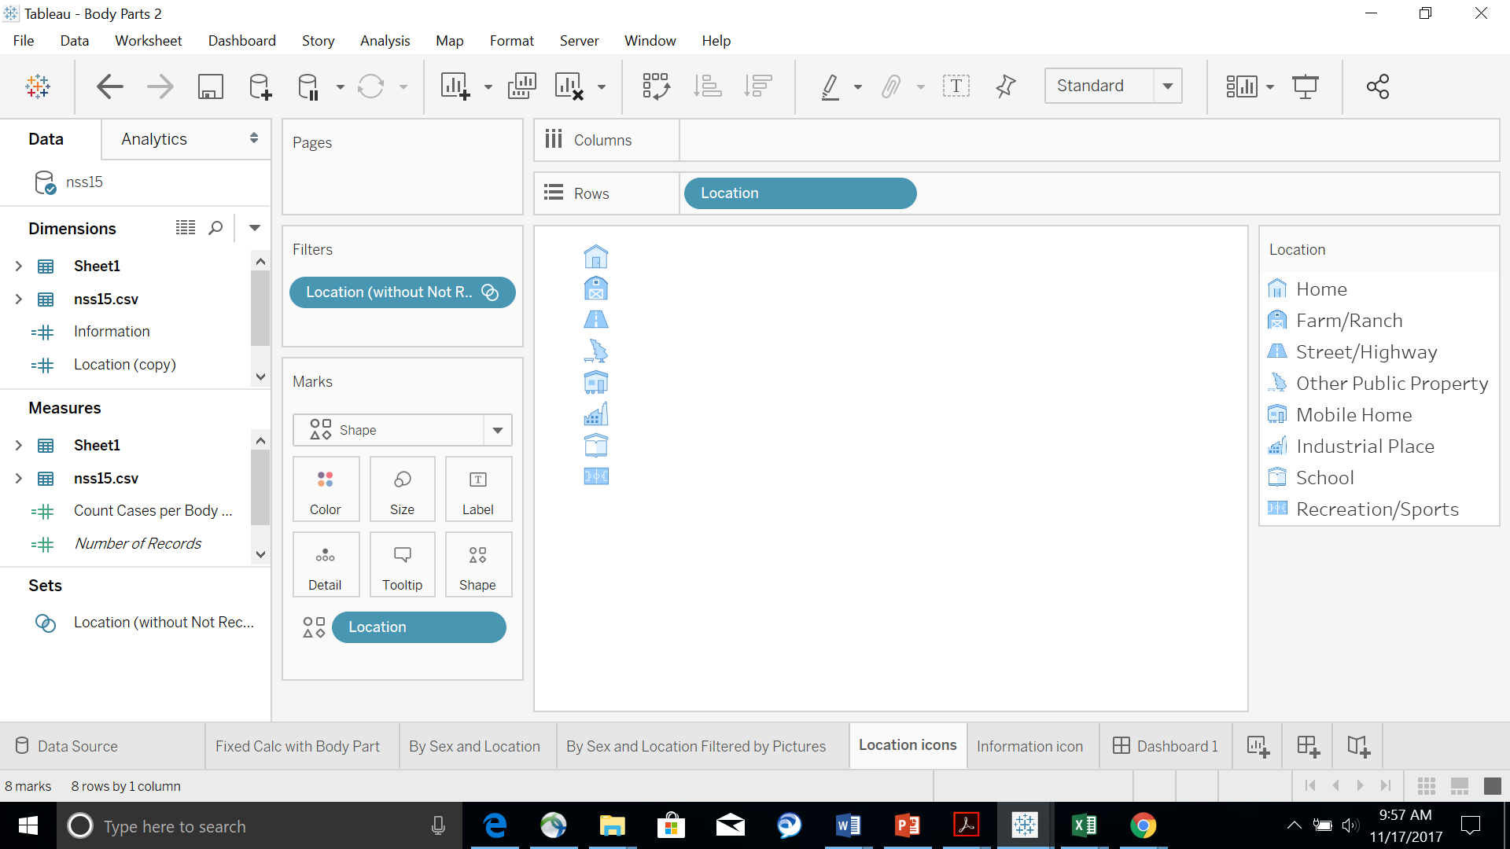

Then make a column like this in your workspace:



1. **Include the “Location Buttons” worksheet in your submitted workbook.**

**Included in submission workbook.**

Next, make the button that will allow people to email you. Create a worksheet called “Contact Button”, and follow the instructions below to make a button on that worksheet that reads “CONTACT”:

<https://www.ryansleeper.com/how-to-add-a-button-to-a-tableau-dashboard/>

Make the tooltip read “Press this button to email me a question!” when you hover over the button. Format the button so that it has black lines along the borders and blue text (similar to the one in the website, but make the borders black instead of grey).

1. **Include the “Contact button” worksheet in your submitted workbook.**

**Included in submission workbook.**

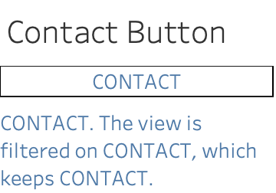

Next, make the information button. Create a worksheet called “Information Button”, and follow the instructions below to create an information button using the information_icon provided in the course materials:

<http://thevizioneer.blogspot.com/2014/04/day-25-hover-for-info.html>

Make the tooltip read “This data set was retrieved from data.world. To learn more about the data, click this information button and the website describing the data set will appear in a web browser.”

1. **Include the “Information Button” worksheet in your submitted workbook.**

**Included in submission workbook.**

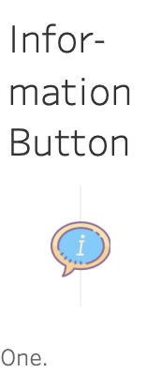

**Exercise 5: Make your first version of a dashboard**

Now you are going to combine the graphical elements you have made into one place using Tableau’s dashboard capability. Review how to arrange dashboard elements here:

<http://onlinehelp.tableau.com/current/pro/desktop/en-us/help.html#dashboards_organize_floatingandtiled.html>

Using fixed dashboard layout containers can be very useful (especially to make your dashboard elements resize automatically), but also very confusing and frustrating (because they randomly change and can be difficult to isolate when you have many of them), so some people religiously use only containers in their dashboards while others use only floating elements. I suggest that you try both, and see which approaches you prefer in different contexts.

This post is helpful for understanding some of the confusing behaviors of containers:

<http://www.bfongdata.com/2015/03/layout-containers-in-tableau.html>

This video series by The Information Lab is also great:

<https://www.youtube.com/watch?v=voAVa4OD_5I>

<https://www.youtube.com/watch?v=NBaDMswMOZU>

<https://www.youtube.com/watch?v=g_gtZRjgSjc>

The third video in The Information Lab series is particularly nice, because it includes an instance when even the author couldn’t figure out why something was happening, and how he solved it.

When you are ready, you are going to make a dashboard that looks approximately like this:

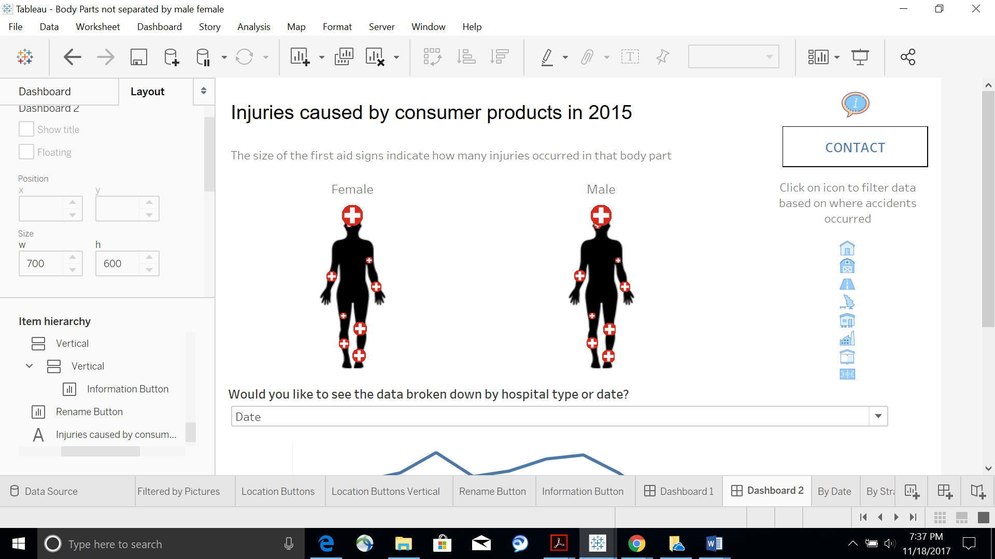

Your dashboard must include the following elements:

* When you hover over the information button, it should say “This data set was retrieved from data.world. To learn more about the data, click this information button and the website describing the data set will appear in a web browser.”
* When you press on the information button, the following website should appear in an internet browser: <https://www.cpsc.gov/Research--Statistics/NEISS-Injury-Data>
* When you hover over the contact button it should say “Press this button to email me a question!”
* When you click on the contact button, an email should come up that:
  + Is addressed to a duke email address
  + Says “question about your dashboard” in the subject line
* When you hover over a location icon it tells you location without the “Location:” prefix (So it should say “Home” instead of “Location: Home”)
* When you press on a location icon, the data on the body images should be filtered by the appropriate location
* When no location icon is selected, the data on the body images should represent all the data **(*including the data with no specified location*)**
* A title
* A subtitle explaining the data on the body images
* Directions about what to do with the location icons

Refer to this reference to help you implement the webpage action that will bring up the NEISS webpage:

<http://onlinehelp.tableau.com/current/pro/desktop/en-us/actions_url.html>

Refer to these references to help you implement the email action:

<http://onlinehelp.tableau.com/current/pro/desktop/en-us/actions_url.html>

<https://community.tableau.com/thread/115428>

Refer to this reference and the videos on the course website to implement the filtering:

<http://onlinehelp.tableau.com/current/pro/desktop/en-us/actions_filter.html>

1. **Call the dashboard “Injuries Dashboard 1”, and include it on your submitted workbook. NOTE: You will be graded based on whether all the pieces of the dashboard are present and function as intended**

**Included in submission workbook.**

**Exercise 6: Make your second version of a dashboard that lets the user choose what type of graph to display**

In this exercise, you are going to add one last feature to your dashboard. You are going to allow the user to decide whether he/she wants to see the data broken down by hospital type or time of the year in addition to gender and/or location, and show the appropriate graph for the user’s choice at the bottom of the dashboard. The basic layout will look like this:

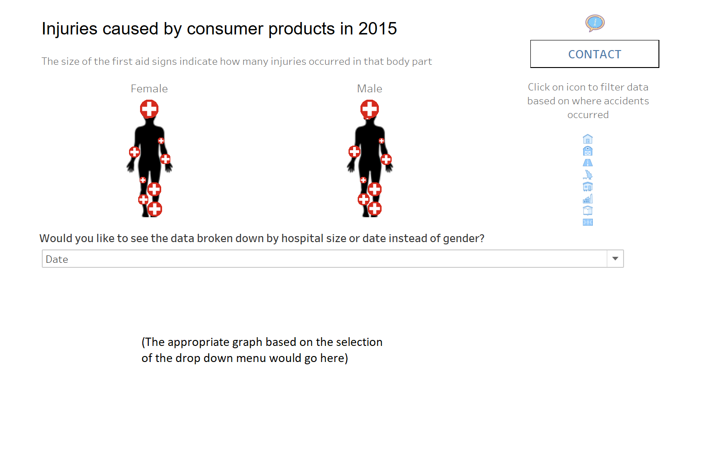

Read both of the following posts to learn how to do this (make sure you read the second one to be able to format the location of the graphs correctly):

<https://www.thedataschool.co.uk/hashu-shenkar/tableau-tip-switch-between-views-dynamically-on-a-dashboard/>

<http://vizdiff.blogspot.com/2016/03/seamless-sheet-swapping.html>

You might also find this video helpful:

<https://www.youtube.com/watch?v=9YzCwsx1I7M>

To get you started, make one worksheet called “By Date” that depicts a line chart with each month of data from 2015 on the x-axis and number of injuries on the y-axis. Make sure to restrict the data shown on the x-axis to only data points from 2015. Remove the chart title and the x-axis title.

Make another worksheet called “By Hospital Size”. In this worksheet, create a bar chart that depicts the number of injuries on the y-axis, and each type/size of hospital on the x-axis. The categories for this chart come from *Stratum*. The aliases for each category in this variable should be adjusted to read:

|  |  |
| --- | --- |
| **Original Value** | **Alias** |
| C | Children’s |
| S | Small |
| M | Medium |
| L | Large |
| V | Very Large |

(In case you are interested, the data set documentation says there were 31 hospitals in the small stratum, 9 hospitals in the medium stratum, 6 hospitals in the large stratum, 15 hospitals in the very large stratum, and 5 hospitals in the children's stratum). Hide the worksheet title and the field label associated with the x-axis.

Then make a dashboard called “Injuries Dashboard 2”, and follow the instructions in the websites provided above to add these functionalities to your dashboard from Exercise 5:

* Make a prompt above where the new graphs will go that reads “Would you like the see the data broken down by hospital size or date?”
* When “Hospital Size” is chosen, the graph from the “By Hospital Size” worksheet should be displayed
* When “Date” is chosen, the graph from the “By Date” worksheet should be displayed
* Both the hospital size and the date graphs should be shown in the same exact location and should be sized to fit the entire view of their container
* Both the hospital size and the date graphs should be filtered by location icons when they are chosen, and should include all the data when no location icons are selected

1. **Include “Injuries Dashboard 2” in your submitted workbook. NOTE: You will be graded based on whether all the pieces of the dashboard are present and function as described.**

**Included in submission workbook.**